|  |
| --- |
| **Sanofi Diabetes Research Grant** |
| Submission Guidelines |
|  |
|  |
|  |
|  |
| **April 2014** |
|  |



# About the Sanofi Diabetes Research Grant

The Sanofi Diabetes Research Grant is awarded to ADEA members to undertake research in the workplace. The provision of $20,000 + GST is an opportunity for individuals to improve their research skills and competence and enhance evidence base for diabetes education and management.

This research grant is restricted to a clinical research project in the field of diabetes education.

Applicants must be a financial member of the Australian Diabetes Educators Association for at least twelve months and have not received a scholarship or grant from ADEA in previous two years.

Credentialled Diabetes Educators or those who are working towards becoming a CDE will be able to claim Credentialling points for completing the proposed research project and presenting the research at the ADS-ADEA Annual Scientific Meeting.

# Conditions of funding

* The amount offered of up to $20,000 + GST for the Sanofi Diabetes Research Grant is subject to the provision of a budget showing estimated expenditures against specified milestones.
* The research project should be segmented into a series of phases identified by specified milestones and costed by phase.
* Funding will not be paid as a single lump sum but will be phased on need and the achievement of milestones. The final milestone, and trigger for the final payment, is to be publication.
* All funds must be acquitted and any unexpended funds at the end of the research are to be refunded to ADEA.
* The funds must:
  + Only be used for the purpose of carrying out the project under this Agreement
  + Include travelling cost, accommodation arrangement and registration for the recipient to attend the 2015 ADS-ADEA Annual Scientific Meeting to present the research findings
  + Not be used to cover the cost of any activities completed prior to the execution of this Agreement
  + Not be used for the purpose of obtaining or complying with any form of loan, credit, payment or other interest, or for the preparation of, or in the course of any litigation

# Eligibility

* Applicants must be a financial member of the ADEA for at least twelve months at the time of application.
* Applicants must not have received a scholarship or grant from ADEA in previous two years.
* Applicants must be supported by their workplace to conduct this research and provide a letter of support from their employer.
* Applicants should complete the Application form attached below including budget with details of how the grant is to be used by **9am Monday 30 June 2014**. All applications will be acknowledged and treated as confidential.

# Selection criteria

The applicant must demonstrate the following:

* The worth of the research in terms of the contribution of the findings to the evidence base for the practice of diabetes education and self-management.
* The ability of the study to offer improved health outcomes to Australians suffering from diabetes.
* The ability to fill gaps in scientific knowledge.
* The project should be able to be completed within a 12 month time frame.

There is no obligation on the assessors to recommend that the research grant be awarded if the quality of the application received is of an unsatisfactory standard.

# Proposed research project

Provide a statement describing the research project.

This Statement should provide:

* Title of research project
* A brief statement of research objectives and aims
* A description of the methodology to be adopted that is sufficient to allow the assessors to determine the appropriateness and rigour of the scientific/statistical methods to be used, and the capacity of the project to achieve its objectives (e.g. rationale for adequate sample sizes and measurement of control bias). This research grant will be awarded to research that demonstrates good science regardless of the method (qualitative or quantitative).
* A statement of how the study will contribute to the body of scholarly knowledge of diabetes education and management. Preference will be given to research that contributes to the body of evidence on the effectiveness of diabetes self management education.

Assessors will value a brief, but comprehensive statement.

This material will assist assessors to judge the quality of your research project.

# Reporting schedule

Any reports, briefing or articles emanating from this research must acknowledge the receipt of a seeding grant from Sanofi Diabetes and ADEA:

***“Supported by Sanofi Diabetes Research Grant”***

* **Project progress reports** are to be provided quarterly in mid January, mid April and mid July 2015.
* **Final project report** must be submitted by mid October 2015.
* An **abstract** of the research findings must be submitted to the [2015 ADS-ADEA Annual Scientific Meeting](http://ads-adea.org.au/).
* An **article** on the research findings must be submitted to the ADEA official publication, the Australian Diabetes Educator by mid September 2015.

All reports should be sent to [applications@adea.com.au](mailto:applications@adea.com.au).

# Timeframe

|  |  |  |
| --- | --- | --- |
|  | Date | Item due |
| 2014 | April | Applications open |
| Monday 30 June | Applications close |
| Friday 25 July | Grant recipient notified |
| Monday 28 July | Photograph and biography for promotional purposes |
| Friday 29 August  ADS-ADEA Annual Scientific Meeting | Recipient announced |
| **August** | **Research project commenced** |
| 2015 | Monday 12 January | 1st progress report |
| Monday 13 April | 2nd progress report |
| Monday 13 July | 3rd progress report |
| March – June | Abstract submission |
| **August** | **Research project completed** |
| Wednesday 27 – Friday 29 August  ADS-ADEA Annual Scientific Meeting | Research findings presentation |
| Monday 14 September | Research article in the ADE publication |
| Monday 12 October | Final report |

# Ethics Committee (EC) Approval

Where relevant, it is a pre-requisite that a research proposal is submitted to the relevant Institution for ethics approval. Please provide evidence that EC approval has been obtained. If not received at the time of application it should be forwarded as soon as received.

# Declaration

This section specifies the conditions attaching to the research grant and your agreement to meeting reporting requirements and participation in promotional activities.

# Contact details

Please direct all inquiries to ADEA National Office at [applications@adea.com.au](mailto:admin@adea.com.au) or 02 6287 4822.

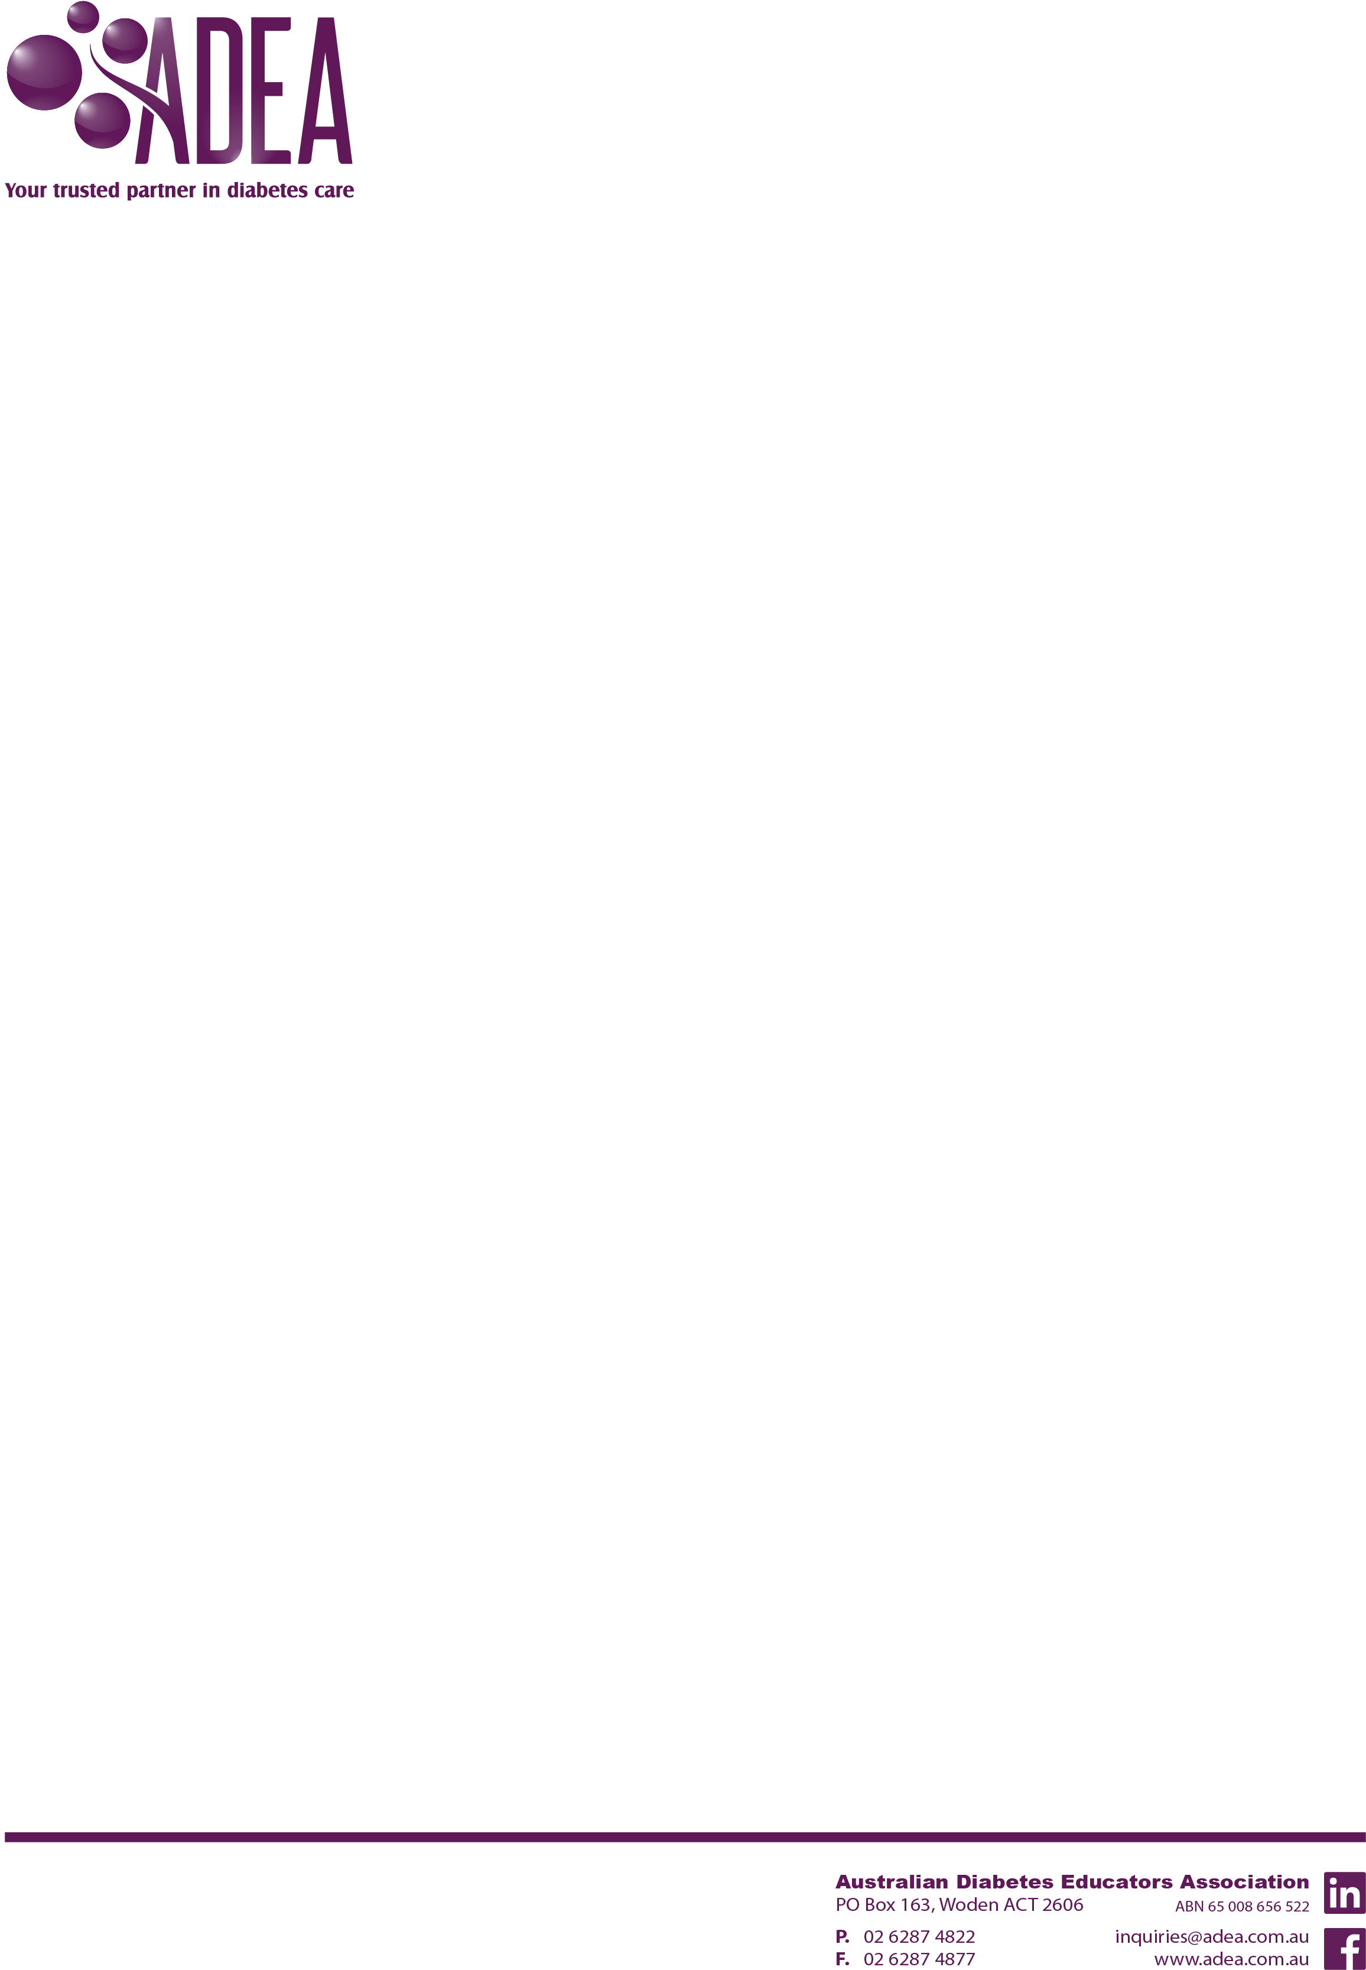

Sanofi Diabetes Research Grant

# Application

Sanofi Diabetes together with ADEA invites applications from ADEA financial members for the Sanofi Diabetes Research Grant, a one-off financial assistance of up to $20,000 + GST to conduct a clinical research project in the field of diabetes education.

Please complete and return this form by 9am Monday 30 June 2014 to [applications@adea.com.au](mailto:applications@adea.com.au).

I, (full name)

(position title) at

(workplace)

hereby submit an application for financial assistance of up to $20,000 + GST to conduct a clinical research project in the field of diabetes education.

# Selection criteria

Please read the submission guideline carefully before completing this application.

## Applicant details

|  |  |  |  |  |  |  |
| --- | --- | --- | --- | --- | --- | --- |
| Title: |  | Given Names: |  | | Surname: |  |
| Mailing Address | | | | | | | |
| Phone (W) | | | | Phone (H) | | | |
| Fax | | | | Email | | | |
| Date of Birth | | | | ADEA Membership No. | | | |

❑ I have updated my ADEA membership details and profile on the ADEA website.

## Proposed research project

Name of institution:

Name of study program:

Employment status: ❑ Full time ❑ Part time

Title of research project:

### Research aim and objectives

Provide enough information for assessors to have a clear understanding. Response must be strictly no more than 200 words.

### A description of the methodology

Provide enough information for assessors to have a clear understanding of how the methodology will ensure the aim and objectives will be met. Response must be strictly no more than 500 words.

### Application of the study

A statement of how the study will contribute to the body of scholarly knowledge of diabetes education and management. Response must be strictly no more than 200 words.

## Funds required

Please provide a payments schedule showing estimated expenditures against specified milestones. This research grant provides funding of up to $20,000 + GST.

|  |  |  |  |
| --- | --- | --- | --- |
| Date | Expenditure | Milestone | Estimated cost |
|  |  |  |  |
|  |  |  |  |
|  |  |  |  |
|  |  |  |  |
|  |  |  |  |
|  |  |  |  |
|  |  |  |  |
|  |  |  |  |
|  |  |  |  |
|  |  |  |  |

## Ethics committee approval

Does your proposed research require approval from an Institution’s Ethics Committee?

❑ Yes, I have received approval. Evidence of ethics Committee approval is attached.

❑ No, I have not yet received approval. Evidence of ethics Committee approval will be provided to ADEA by

*(Please specify timeline)*

## Additional information

Have you applied for other funding for this research?

❑ Yes, I have applied for funding provided by

*(Please specify the funding provider)*

❑ No

Have you been successful with that application?

❑ Yes, the amount received is $

*(Please specify the amount)*

❑ No

Are you supported by your workplace to conduct this research?

❑ Yes, I have their support. A letter of support is attached.

❑ No

## Declaration

If successful in this application, I agree to:

* Supply a photograph and short biography for promotional purposes
* Provide ADEA with 3 progress reports according to reporting schedule requested in the submission guidelines
* Provide ADEA with the various documents required for this application (e.g. written approval from the Institution’s Ethics Committee)
* Present the outcome of the research at the ADS-ADEA Annual Scientific Meeting and publish in the Australian Diabetes Educator publication according to reporting schedule
* Acknowledge ADEA support on all relevant presentations and publications arising from the research project:

***“Supported by Sanofi Diabetes Research Grant”***

Name:

Signature:

Date:

* Applications to be submitted to [applications@adea.com.au](mailto:admin@adea.com.au) by **9am Monday 30 June 2014** *